DD1) GPA – numerical, actual GPA–rating

2) Gender

(1 – Female

2 – Male)

3) Breakfast (the participants are shown the following pictures and asked which one of these pictures they associate with the word “breakfast), 1 – cereal option and 2 – donut op



–4) calories_chicken - guessing calories in chicken piadina:

1 - 265

2 - 430

3 - 610

4 – 720

(the variable shows the actual number of calories participants selected)

5) calories_day - Importance of consuming calories per day

1 - i don't know how many calories i should consume

2 - it is not at all important

3 - it is moderately important

4 - it is very important

6) calories_scone score - Guessing calories in a scone from starbucks

1 - 107 cal

2 - 315 cal

3 - 420 cal

4 - 980 cal

(the variable shows the actual number of calories participants selected)

7) coffee – which of the two pictures you associate with the word coffee?

1 – creamy frappuccino

2 – espresso shown





8) comfort_food - List 3-5 comfort foods that come to mind.

Open ended (perfect for NLP)

—9) comfort_food_reasons - What are some of the reasons that make you eat comfort food? (i.e., anger, sadness, happiness, boredom, etc) - list up to three

Open ended (perfect for NLP)

–10) comfort_food_reasons_coded

(the one mentioned first)

1 – stress

2 – boredom

3 – depression/sadness

4 – hunger

5 – laziness

6 – cold weather

7 – happiness

8 - watching tv

9 – none

11) cook – how often do you cook?

1 - Every day

2 - A couple of times a week

3 - Whenever I can, but that is not very often

4 - I only help a little during holidays

5 - Never, I really do not know my way around a kitchen

12) cuisine – what type of cuisine did you eat growing up?1 – American

2 – Mexican.Spanish

3 – Korean/Asian

4 – Indian

5 – American inspired international dishes

6 – other

(lots of cleaning needed for this variable)

13) diet_current – describe your current diet

open ended – ideal for NLP

14) diet_current_coded

(based on words used to describe the diet)

1 – healthy/balanced/moderated/

2 – unhealthy/cheap/too much/random/

3 – the same thing over and over

4 – unclear

15) Which picture do you associate with the word “drink”?

1 – orange juice

2 – soda

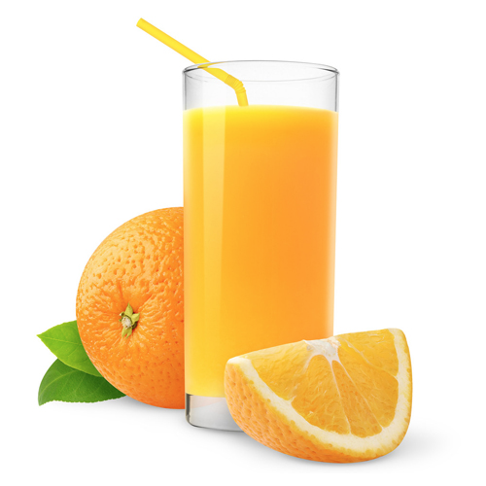



16) eating_changes - Describe your eating changes since the moment you got into college?

Open ended

17) eating_changes_coded

1 – worse

2 – better

3 – the same

4 – unclear

18) eating_changes_coded1

1 – eat faster

2 – bigger quantity

3 – worse quality

4 – same food

5 – healthier

6 – unclear

7 – drink coffee

8 – less food

9 – more sweets

10 – timing

11 – more carbs or snacking

12 – drink more water

13 – more variety

19) eating_out - frequency of eating out in a typical week

1 - Never

2 - 1-2 times

3 - 2-3 times

4 - 3-5 times

5 - every day

20) employment – do you work?

1 - yes full time

2 - yes part time

3 – no

4 - other

21) ethnic_food - How likely to eat ethnic food

1 - very unlikely

2 - unlikely

3 - neutral

4 - likely

5 - very likely

22) exercise – how often do you exercise in a regular week?

1 - Everyday

2 - Twice or three times per week

3 - Once a week

4 - Sometimes

5 – Never

23) father_education –

1 - less than high school

2 - high school degree

3 - some college degree

4 - college degree

5 - graduate degree

24) father_profession – what is your father profession?

Open ended

25) fav_cuisine - What is your favorite cuisine?

Open ended

26) fav_cuisine_coded

0-none

1 – Italian/French/greek

2 – Spanish/mexican

3 – Arabic/Turkish

4 – asian/chineses/thai/nepal

5 – American

6 – African

7 – Jamaican

8 – indian

27) fav_food - was your favorite food cooked at home or store bought?

1 - cooked at home

2 - store bought

3 - both bought at store and cooked at home

28) food_childhood – what was your favorite childhood food?

Open ended

29) which of these pictures you associate with word fries?

1 – Mcdonald’s fries

2 – home fries

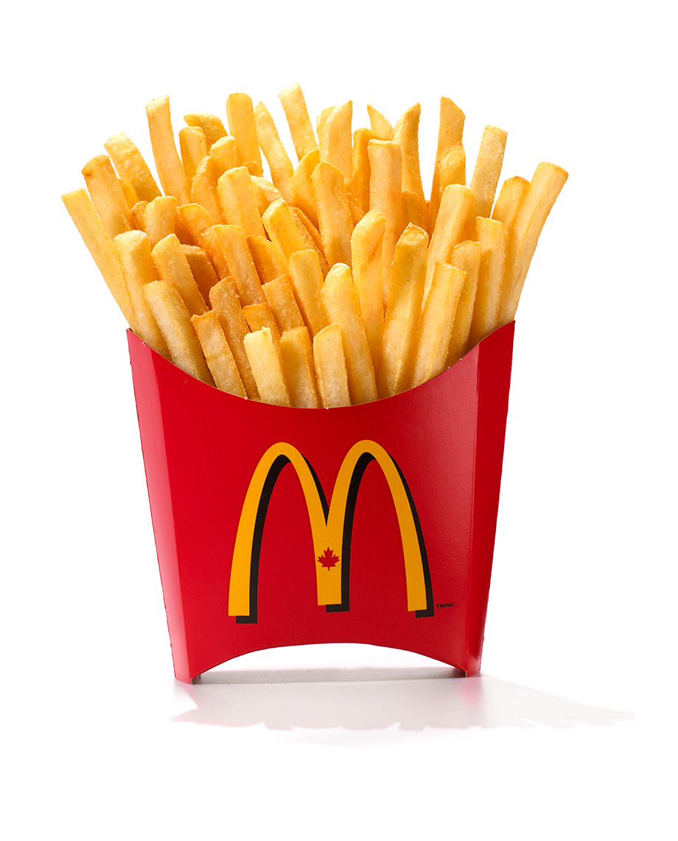

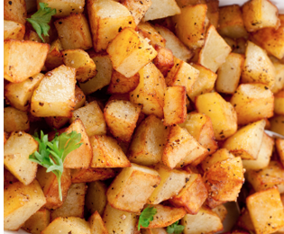

30) fruit_day - How likely to eat fruit in a regular day

1 - very unlikely

2 - unlikely

3 - neutral

4 - likely

5 - very likely

31) grade_level –

1 - freshman

2 -Sophomore

3 - Junior

4 - Senior

32) greek_food - How likely to eat greek food when available?

1 - very unlikely

2 - unlikely

3 - neutral

4 - likely

5 - very likely

33) healthy_feeling – how likely are you to agree with the following statement: “I feel very healthy!” ?

1 to 10 where 1 is strongly agree and 10 is strongly disagree - scale

34) healthy_meal – what is a healthy meal? Describe in 2-3 sentences.

Open ended

35) ideal_diet – describe your ideal diet in 2-3 sentences

Open ended

36) Ideal_diet_coded

1 – portion control

2 – adding veggies/eating healthier food/adding fruit

3 – balance

4 – less sugar

5 – home cooked/organic

6 – current diet

7 – more protein

8 – unclear

37) income

1 - less than $15,000

2 - $15,001 to $30,000 3 - $30,001 to $50,000

4 - $50,001 to $70,000

5 - $70,001 to $100,000

6 - higher than $100,000

38) indian_food – how likely are you to eat indian food when available

1 - very unlikely

2 - unlikely

3 - neutral

4 - likely

5 - very likely

39) Italian_food – how likely are you to eat Italian food when available?

1 - very unlikely

2 - unlikely

3 - neutral

4 - likely

5 - very likely

40) life_rewarding – how likely are you to agree with the following statement: “I feel life is very rewarding!” ?

1 to 10 where 1 is strongly agree and 10 is strongly disagree - scale

41) marital_status

1 -Single

2 - In a relationship

3 - Cohabiting

4 - Married

5 - Divorced

6 - Widowed

42) meals_dinner_friend – What would you serve to a friend for dinner?

Open ended

43) mother_education

1 - less than high school

2 - high school degree

3 - some college degree

4 - college degree

5 - graduate degree

44) mother_profession – what is your mother’s profession?

45) nutritional_check - checking nutritional values frequency

1 - never

2 - on certain products only

3 - very rarely

4 - on most products

5 - on everything

46) on_off_campus – living situation

1 - On campus

2 - Rent out of campus

3 - Live with my parents and commute

4 - Own my own house

47) parents_cook - Approximately how many days a week did your parents cook?

1 - Almost everyday

2 - 2-3 times a week

3 - 1-2 times a week

4 - on holidays only

5 - never

48) pay_meal_out - How much would you pay for meal out?

1 - up to $5.00

2 - $5.01 to $10.00

3 - $10.01 to $20.00

4 - $20.01 to $30.00

5 - $30.01 to $40.00

6 - more than $40.01

49) Persian_food - How likely to eat persian food when available?

1 - very unlikely

2 - unlikely

3 - neutral

4 - likely

5 - very likely

50) self_perception_weight - self perception of weight

6 - i dont think myself in these terms

5 - overweight

4 - slightly overweight

3 - just right

2 - very fit

1 - slim

51) Which of the two pictures you associate with the word soup?

1 – veggie soup

2 – creamy soup

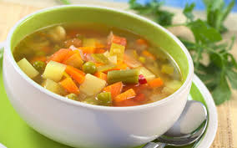

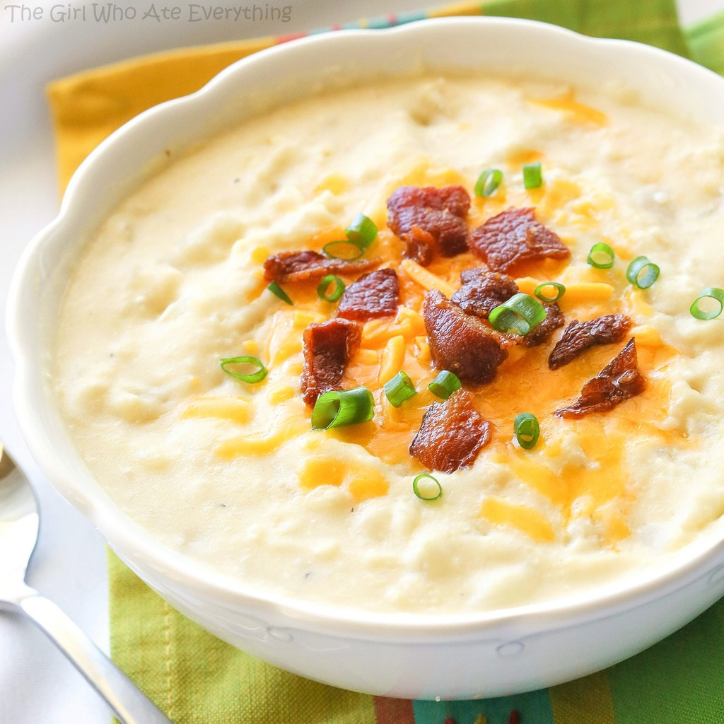

52) sports - sports – do you do any sporting activity?

1 - Yes

2 - No

99 – no answer

53) thai_food - How likely is it to eat thai food when available?

1 - very unlikely

2 - unlikely

3 - neutral

4 - likely

5 - very likely

54) tortilla_calories - guessing calories in a burrito sandwich from Chipotle?

1 - 580

2 - 725

3 - 940

4 - 1165

55) turkey_calories - Can you guess how many calories are in the foods shown below? (Panera Bread Roasted Turkey and Avocado BLT)

1 - 345

2 - 500

3 - 690

4 - 850

56) type_sports – what type of sports are you involved in?

Open-ended

57) veggies_day - How likely are you to eat veggies in a day?

1 - very unlikely

2 - unlikely

3 - neutral

4- likely

5 - very likely

58) vitamins – do you take any supplements or vitamins?

1 – yes

2 – no

59) waffle_calories - guessing calories in waffle potato sandwich

1 - 575

2 - 760

3 - 900

4 - 1315

60) weight – what is your weight in kgs

1-80-100

2-60-79

3 50-59